Payment Integrity Concept Development & Governance Framework
Nov 1, 2026 · @Samuel

1. Executive summary
Every payment integrity concept — DRG, APC, HBA or any future program — moves through one governed lifecycle of ten stages and eight gates, from intake to retirement. No concept reaches production without documented analytical, guideline, denial-evidence, SME and business approval, and every production concept is re-scored monthly so weak performers flow back as LPQs instead of silently decaying.
The framework is built on four commitments:
- One lifecycle, many programs. Gates, tiers, overlap logic, KPIs and RACI are common; program-specific coding and reimbursement logic plugs in as a module.
- Incrementality over volume. A concept earns its place by the claims and dollars no existing model or concept already catches — measured with model overlap, Jaccard similarity and overlap coefficient.
- Sustained findings, not raw hits. As a payer-side team, success is an overpayment that survives provider appeal. Appeal and overturn rates are first-class quality metrics at SME validation, estimation, monitoring and LPQ classification.
- Configurable, evidence-based thresholds. Every percentage lives in a parameter register (section 15) with an owner, a current baseline and a calibration method — none are hard-coded in this framework.
The operational to-dos this framework supports: Databricks and VS Code integration of the concept framework, a multi-concept data pull and estimation engine, and pod-wise initiation-to-approval reporting (section 16).

2. Design principles and program-module architecture
Governance is centralized; clinical, coding and reimbursement logic is modular. Each program registers a module that answers the same questions, so the common gates never assume DRG or APC rules.
Layer | Common core (all programs) | Program module (DRG, APC, HBA, future)
Concept definition | Concept ID, card, owner, version, status | Target types (MS-DRG, MCC/CC, PDX, APC, CPT/HCPCS, revenue code), valid actions
Actions | Action taxonomy and codes | Which actions apply (e.g., PDX switch is DRG-only; units correction is outpatient-led)
Financial impact | Estimation formula and $ stages | Re-grouping or re-pricing logic (grouper, APC pricer, fee schedule)
Overlap | Model overlap, Jaccard, overlap coefficient, decision matrix | Network key (e.g., same DRG; same APC family)
Guidelines | Registry structure, policy gate, change impact | Sources: ICD-10-CM/PCS Official Guidelines, Coding Clinic, CPT/NCCI, NCDs/LCDs, payer policy
Denials and appeals | Taxonomy, finding lifecycle, overturn metrics | Program-specific reason codes and appeal routes
Tiering | T1–T3 definitions and their effect on rigor | What counts as a "code family" or "category family"
Monitoring | KPIs, LPQ scoring, lifecycle decisions | Program baselines for hit rate and recovery
Principles applied throughout:
- Analytical accuracy (the query picks the intended claims), clinical validity (the finding is right) and financial recoverability (the money is realized and sustained) are measured separately.
- Every threshold is a named parameter with a baseline and calibration evidence; tier can tighten or loosen it.
- Every concept, query version, threshold change and approval is versioned and auditable.
- Automated outputs (overlap scores, LPQ flags, guideline matches) are recommendations; clinical, coding and payment determinations stay with qualified reviewers.
- Production results feed back into intake, so the lifecycle is a loop, not a line.

3. End-to-end lifecycle
New concepts and LPQs share one path: ten stages, eight gates, four exits, and a loop that sends weak production concepts back through the same gates.
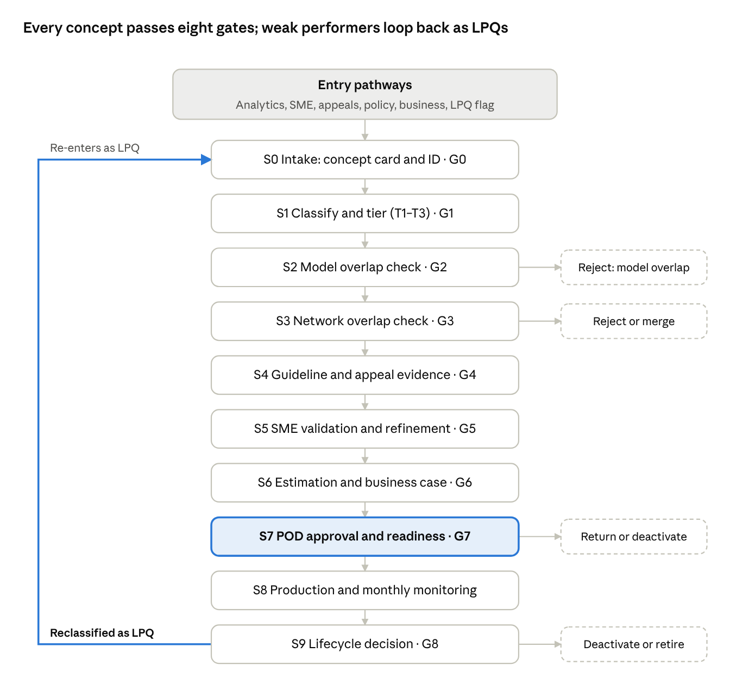
concept lifecycle · 10 stages, 8 gates, LPQ loop
Approval (S7) is the single point where a concept becomes production; everything above it builds the evidence, everything below it tests whether that evidence held.

4. Stage-wise operating model
Ten stages, each closed by a gate (G0–G8). New concepts enter at S0; LPQs enter at S0 with a remediation flag and run the same gates with a version comparison added. Parameter IDs (P-xx) refer to section 15.
Stages, activities and decisions
Stage | Objective | Inputs | Key activities and method | Decision | Output
S0 Intake | Capture a complete, unique concept | Discovery analytics, SME idea, appeal/denial trend, policy change, LPQ flag, business request | Fill concept card; assign concept ID; duplicate-name check against registry | Complete and unique? | Registered concept (status: Intake)
S1 Classify and tier | Set rigor level | Concept card | Assign program module, action, reason, tier T1–T3 | Tier assigned | Tier and applicable parameter set
S2 Model overlap | Avoid paying twice for what models catch | Draft query claim set; model outputs | Share of concept claims and $ flagged by high-confidence (green/amber) models | Reject / remove overlap and proceed | Incremental claim set
S3 Network overlap | Avoid duplicating existing concepts | Incremental claim set; production concepts in same network | Jaccard, overlap coefficient, directional containment; hit-rate duel if intermediate | Reject / merge / compare / proceed | Overlap verdict; LPQ referral for weak existing concept
S4 Evidence validation | Prove the concept is defensible | Guideline registry; denial and appeal repository | Map to guideline citation and effective dates; check overturn history for same reason | Policy-supported and appeal-defensible? | Guideline and evidence record
S5 SME validation and refinement | Prove findings are clinically and coding-valid | Stratified sample | SME review; false-positive root cause; refine logic; recalculate hit rate | Hit rate and expected sustain rate above tier floor? | Validated query version
S6 Estimation | Size the opportunity honestly | Validated hit rate, volumes, recovery per finding, overturn rate | Standard formula (section 11) with confidence level | Above P-EST-MIN? | Business case
S7 Approval and readiness | Formal authorization | Concept dossier | POD review, readiness checklist, sign-offs per RACI | Approve / return / deactivate | Approved version, production ID
S8 Production and monitoring | Track real performance | Production results, appeals, policy changes | Monthly scorecard; LPQ score | Healthy / watch / LPQ | Health status
S9 Lifecycle decision | Act on performance | Scorecard trend | Retain, optimize, expand, merge, reclassify as LPQ, deactivate | Decision logged | Updated status and version
Gate entry and exit criteria
Gate | Entry criteria | Exit criteria | Stage KPI
G0 Intake | Request with sponsor and rationale | Concept card complete; unique ID; owner and requesting POD named | Intake-to-tier days
G1 Tier | G0 passed | Program module, action code, reason code, tier recorded | % concepts re-tiered later
G2 Model overlap | Draft query runs on agreed claim window | Model overlap below P-MO-REJ (tier-adjusted); overlap claims excluded | Rejection rate for model overlap
G3 Network overlap | Incremental claim set exists | Matrix verdict recorded; any hit-rate duel concluded; LPQ referrals raised | Redundancy rejection rate
G4 Evidence | Overlap verdict = proceed or merge | Guideline citation with effective DOS range; denial reason code; overturn history reviewed against P-OVT-MAX | % concepts with full citation
G5 SME | Evidence record complete | Sample size meets P-SMP for tier; hit rate ≥ P-HR-MIN; SME sign-off; false-positive causes documented | Refinement success rate; SME turnaround
G6 Estimation | SME-validated version | Estimate, assumptions and confidence level documented; ≥ P-EST-MIN | Estimate accuracy (later vs realized)
G7 Approval | Full dossier | All sign-offs per RACI; readiness checklist complete; version locked | Time to approval; approval ratio
G8 Lifecycle | Monitoring period(s) complete | Decision and rationale logged; LPQ routed back to S0 if applicable | LPQ %, remediation success
Production readiness checklist (G7): locked query version in Git; parameter set recorded; guideline citation current for DOS window; SME sign-off; estimate with confidence level; model and network overlap results attached; appeal-defense rationale written for recovery teams; monitoring baseline set; rollback plan.

5. Concept intake
All six entry pathways produce the same concept card, so downstream gates never depend on where an idea came from.
Pathway | Typical trigger | Extra intake evidence
Analytics discovery | Outlier coding pattern, MCC/CC capture spike, unusual PDX mix | Query result profile and baseline rates
SME-identified | Clinical, coding or documentation pattern seen in review | Example claims and rationale
Denial and appeal-driven | Recurring finding type, or overturn trend showing a gap | Repository extract (section 10)
Guideline and policy-driven | New or revised guideline, Coding Clinic, NCD/LCD, payer policy | Registry entry and effective date
LPQ remediation | LPQ flag from monitoring | Scorecard history, current version
Business and strategic | Leadership priority, contract change | Sponsor and objective
Concept ID convention: {PROGRAM}-{TARGET}-{ACTION}-{REASON}-v{n}, for example DRG-871-J9601-DXDROP-CNS-v1 (DRG 871, drop J96.01, clinically not supported) or DRG-871-PDXSW-SEQ-v2. Queries under one concept carry a suffix (-Q01).
Action code | Meaning | Reason code | Meaning
DXDROP | Secondary diagnosis drop (MCC/CC) | CNS | Clinically not supported
DXSWAP | Diagnosis swap to a different code | DOCINC | Documentation inconsistency
PDXSW | Principal diagnosis switch | CODGL | Coding guideline violation
PXDROP | Procedure drop | SEQ | Sequencing error
MODCOR | Modifier correction | MEDNEC | Medical necessity not met
UNITCOR | Units correction | BUNDLE | Bundling or unbundling
Codes are owned by the governance team and extended per program module.
Concept card (mandatory fields): concept ID and title; program module; objective and business rationale; target codes, populations, claim types and DOS window; proposed action; denial rationale (reason code) and supporting guideline; expected outcome (DRG/APC shift); expected financial opportunity (rough order); concept owner, requesting POD, SME lead; pathway; linked concepts in the same network; status and version.

6. Tier classification
Tier measures specificity and breadth: the broader the concept, the more claims it touches, the more it overlaps with others, and the more rigor it needs before production.
Tier | Definition | Example (DRG module) | Example (APC module)
T1 | One specific code on one specific reimbursement category | J96.01 drop on DRG 871 | One CPT units correction on one APC
T2 | Code family or category family | J96.x drop across DRG 870–872 | Modifier correction across an APC family
T3 | Broad, multi-code and multi-category | Any respiratory-failure MCC drop across all medical DRGs | Bundling logic across many APCs
Tier is assigned by rule, not judgment: count distinct target codes and distinct categories in the query, compared with the module's family definitions. Re-tier whenever a refinement changes the target set.
How tier changes the rules
Control | T1 | T2 | T3 | Why
Model overlap tolerance | Base P-MO-REJ | Base minus P-TIER-ADJ | Base minus 2 × P-TIER-ADJ | Broad concepts are likelier to re-find model claims
Network overlap bands | Base | Base | Tighter high band; overlap coefficient mandatory | Broad concepts often contain narrower ones
SME involvement | One coder or SME | Coder plus clinical SME | Coder, clinical SME and second-level review | Heterogeneous claims need more expertise
Sample size | Base P-SMP | Stratified by code family | Stratified by code and category; minimum per stratum | Hit rate must hold in every stratum, not on average
Approval authority | POD lead | POD lead plus governance board | Governance board plus leadership | Financial and abrasion exposure scale with breadth
Documentation rigor | Standard dossier | Plus stratum results | Plus provider-abrasion assessment and phased rollout plan | Large blast radius if wrong
Monitoring | Monthly | Monthly | Monthly, with early LPQ trigger (P-LPQ-PER halved for first 2 periods) | Early detection of drift
All adjustments are parameters (section 15), so the governance board can tune them without rewriting the framework.

7. Model and network overlap
Overlap is checked twice: first against models (S2), then against other concepts in the same network (S3). A network is every production or in-flight concept sharing the module's network key — for DRG, the same DRG (e.g., DRG 871 MCC drop and DRG 871 PDX switch).
Model overlap (S2)
Model overlap = share of the concept's claims (and dollars) already flagged by high-confidence model outputs (green and amber top claims). Measure both counts and dollars; a concept can overlap little by count but heavily by dollars.
- Above P-MO-REJ (tier-adjusted): reject.
- At or below: remove the overlapping claims and carry only the incremental set forward.
Network overlap metrics (S3)
For new concept claim set A and existing concept claim set B, on the same claim window:
J(A,B) = \frac{|A \cap B|}{|A \cup B|} \qquad OC(A,B) = \frac{|A \cap B|}{\min(|A|,|B|)} \qquad C(A \to B) = \frac{|A \cap B|}{|A|}
Metric | Answers | Strength | Limitation
Jaccard (J) | How similar are the two claim sets overall? | Symmetric; penalizes size mismatch; good for near-duplicates | Understates nesting: a 1,000-claim query fully inside a 10,000-claim query scores J = 0.10
Overlap coefficient (OC) | Is one query largely inside the other? | Detects subset and nested queries | Symmetric — does not say which one is nested
Containment C(A→B) | What share of the new concept is already caught? | Directional; ties straight to incremental value | Ignores how much of B is untouched
Use J for similarity, OC to detect nesting, and containment to decide incrementality.
Decision matrix
Band | Rule | Action
High | J ≥ P-NO-HIGH, or C(A→B) ≥ P-NO-HIGH | Reject as duplicate, or merge into existing concept as a new version
Nested | OC ≥ P-OC-NEST and J below P-NO-HIGH | If A ⊂ B: treat as a refinement of B and compare. If B ⊂ A: A is broader — re-tier and compare.
Intermediate | P-NO-LOW ≤ J < P-NO-HIGH | Hit-rate duel (below)
Low | J < P-NO-LOW and OC < P-OC-NEST | Retain original intent; proceed to S4
The bands are contiguous by construction, so no overlap value falls between routes (the earlier 50–60% gap is closed).
Hit-rate duel (intermediate and nested bands)
- Split claims into three strata: A only, A ∩ B, B only.
- SME-review a stratified sample from each stratum (sample size per P-SMP).
- Combine with B's production history: hit rate, realized recovery per finding, overturn rate.
- Compare on overturn-adjusted hit rate and net recovery per reviewed claim, not raw hit rate.
Duel result | Action on new concept (A) | Action on existing concept (B)
Existing is better | Remove A ∩ B from A; proceed on A-only if it clears estimation | No change
New is better | Keep full intent | Overlap claims ceded to A; B referred to LPQ track for remediation or deactivation
Comparable | Merge candidates: build combined version | Retired into merged version

8. New concept vs LPQ decision tree
New concepts and remediated LPQ versions run the same overlap tree; the one link between tracks is the highlighted outcome, where a stronger new concept sends the weaker existing one into LPQ remediation.
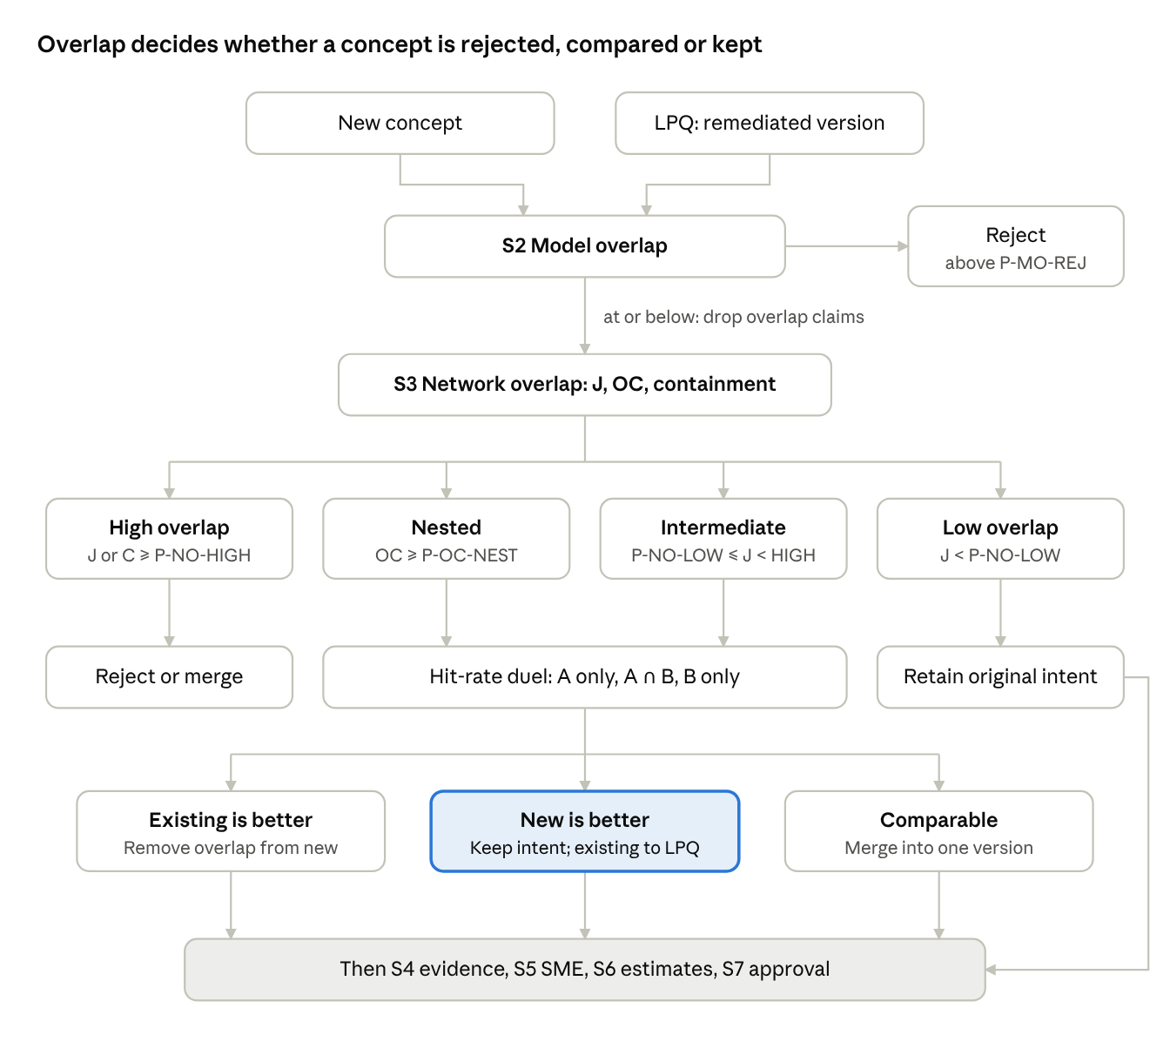
overlap decision tree · new concepts and LPQ versions
An LPQ version is compared both with its own prior version (section 11) and with its network, so remediation cannot reintroduce duplication.

9. Guideline intelligence
Every concept must cite the rule that makes its finding correct, valid for the dates of service it targets. A central Guideline Registry holds those rules and their versions; the policy gate (G4) blocks any concept without a current citation.
Registry content
Source type | Examples | Key fields
Coding guidelines | ICD-10-CM/PCS Official Guidelines, Coding Clinic, CPT, NCCI edits | Section reference, fiscal-year version
Clinical guidelines | Clinical criteria used for clinical validation (e.g., accepted criteria for respiratory failure, sepsis) | Criteria version, source body
Reimbursement rules | MS-DRG definitions, OPPS/APC rules, grouper version | Grouper/pricer version, DOS range
CMS policy and regulation | Manuals, NCDs, LCDs, MA requirements | Effective and end dates, jurisdiction
Payer policy and contracts | Internal payment policies, provider contract terms | Applicable lines of business and contracts
Documentation requirements | What the record must show to support a code | Linked codes
Each entry carries: registry ID, source, citation, effective date, end date, applicability (program, line of business, setting), linked concepts, owner and version history. Superseded versions are kept, never overwritten, so a claim is always judged against the rule in force on its date of service.
Concept-to-guideline mapping (required at G4): concept ID ↔ registry ID(s), the specific requirement relied on, DOS range covered, and the documentation element SMEs check. A concept whose DOS window extends past a registry entry's end date fails G4 until re-mapped.
Policy change impact process
- Registry update logged (new, revised or retired guideline).
- Impact assessment: list every concept linked to the entry, plus concepts in the same network.
- Query review: does the logic still match the new rule and DOS split?
- SME reassessment for affected concepts; tag as Watch in monitoring.
- Production update as a new version, or deactivation if the basis is gone; prior version stays valid for earlier DOS.
Target: impact assessment complete within P-POL-SLA days of the effective date.

Guideline specificity and intent alignment score
Each concept gets a 0–100 Intent Alignment Score (IAS) showing how directly a guideline supports its action and how faithfully the query and its findings follow that guideline. It is scored at G4, re-scored after SME validation and refreshed quarterly in production.
Guideline specificity levels (of the strongest citation the concept relies on):
Level | Basis | Example | Specificity score
GS1 | Explicit coding or reimbursement rule that directly dictates the action | Official Guidelines sequencing rule; NCCI edit | 100
GS2 | Authoritative interpretive guidance | Coding Clinic Q&A on the exact scenario | 75
GS3 | Clinical criteria requiring reviewer judgment | Accepted clinical criteria for respiratory failure or sepsis | 50
GS4 | Payer policy or internal standard only | Internal clinical validation policy | 25
Point values are defaults, held as P-GS-PTS.
Alignment components
Component | What it measures | How scored (0–100)
Specificity (S) | Strength of the guideline basis | Level points above
Logic fidelity (F) | Share of the guideline's conditions encoded in the query (codes, exclusions, documentation elements, DOS range) | Conditions encoded ÷ conditions required, from a checklist reviewed by the SME
Reason concordance (R) | Share of SME-validated findings whose actual reason matches the concept's stated reason code | Matching ÷ validated findings
Appeal defensibility (D) | Survival on appeal for guideline-related reasons | 100 × (1 − overturns for "guideline misapplied" or "clinical criteria disputed" ÷ appeals decided)
Currency (C) | Share of targeted claims whose DOS falls inside the cited guideline's effective range | In-range claims ÷ targeted claims
IAS = w_S S + w_F F + w_R R + w_D D + w_C C, \qquad \textstyle\sum w = 1
Weights are P-IAS-W (suggested starting point: equal). Before production history exists, D uses the network's reason-code history and is flagged as provisional.
Alignment bands: Aligned (IAS ≥ P-IAS-HIGH); Partially aligned (between); Drifted (IAS < P-IAS-LOW). A Drifted concept fails G4, and a production concept that drifts goes to Watch with a guideline review, whatever its financial performance.

10. Denial, appeal and overturn intelligence
For a payer-side team, the real test of a concept is whether its findings survive provider appeal. The Denial and Appeal Repository links every finding from query hit to final outcome, so concepts are judged on sustained recovery, not raw hits.
Finding lifecycle — keep these stages distinct
Stage | Meaning | Who decides
Query hit | Claim picked by concept logic | Analytics
Validated finding | Reviewer confirms the coding or clinical error | Coder or clinical SME
Issued finding | Overpayment notice or adjustment sent to provider | Recovery operations
Appealed | Provider disputes the finding | Provider
Sustained / overturned | Appeal decision upheld or reversed (by level) | Appeals team, external reviewer
Realized recovery | Dollars actually recovered, net of overturns | Finance
Also keep separate: provider-side remit denials (CARC/RARC on adjusted claims), payer audit findings (this lifecycle), external audit findings, and final overpayment determinations. Only sustained determinations count as proven overpayments.
Repository content: finding ID and concept ID/version; action and reason codes; CARC/RARC applied; appeal level and dates; outcome; overturn reason (structured category plus free-text narrative); dollars issued, overturned and recovered.
Common taxonomy: medical necessity; documentation insufficiency; coding discrepancy (diagnosis, procedure, sequencing); reimbursement classification (DRG/APC assignment); bundling and duplicate billing; coverage and policy restriction; other payment integrity. Overturn reasons use the same taxonomy plus: guideline misapplied, documentation found on appeal, clinical criteria disputed, procedural or timeliness.
Appeal and overturn metrics
\text{Appeal rate} = \frac{\text{appealed findings}}{\text{issued findings}} \qquad \text{Overturn rate} = \frac{\text{overturned}}{\text{appeals decided}} \qquad \text{Sustain rate} = 1 - \frac{\text{overturned}}{\text{issued findings}}

\text{Overturn-adjusted hit rate} = \text{SME hit rate} \times \text{sustain rate}
Track each by concept, version, reason code, tier, provider and POD, in counts and dollars, with appeal turnaround days.
How this intelligence is used
- New concepts: recurring sustained findings outside existing concepts, and overturn patterns exposing gaps, become intake ideas.
- Existing concepts: overturn reasons drive refinement (e.g., exclude records where a supporting element is commonly found on appeal).
- LPQ detection: overturn rate above P-OVT-MAX for P-LPQ-PER periods triggers LPQ review even when hit rate looks healthy.
- Estimation: expected overturn rate is a direct input (section 11).
Denial evidence gate (G4): the concept states its reason code and taxonomy category; history of overturns for that reason, code and network is reviewed; a new concept in a category with overturn rate above P-OVT-MAX needs a written appeal-defense rationale and SME lead sign-off.

11. SME validation and financial estimation
SME validation proves the findings are right; estimation sizes what will actually be recovered after overlap and overturns. Both pathways — new concept and LPQ remediation — share these methods.
SME validation (S5)
- Population: incremental claim set after S2 and S3, on an agreed claim window.
- Sample: stratified random sample (by code, category and provider for T2/T3). Size per stratum from the binomial margin-of-error formula below, using P-SMP-E (margin) and P-SMP-Z (confidence), floored at P-SMP-MIN.
- Review: coder and/or clinical SME per tier; outcome per claim = valid finding, not valid, insufficient documentation; reason recorded.
- False-positive analysis: categorize every invalid claim (logic gap, documentation present, guideline nuance, data issue).
- Refinement: add exclusions or tighten logic for the top false-positive causes; re-run S2–S3 if the claim set changes materially (above P-REF-CHG).
- Recalculate: hit rate and confidence interval on the refined version; report incremental claims and $ versus prior version.
n = \frac{z^{2}\, p\,(1-p)}{e^{2}}
Use p from a pilot or 0.5 if unknown. Exit G5 only if the lower bound of the hit-rate interval clears P-HR-MIN for the tier.
LPQ remediation additions: root-cause the decline (logic, coding behavior change, guideline change, rising overturns); compare old vs new version on the same claims; post-remediation SME validation is mandatory before re-approval.
Estimation (S6)
\text{Est. recovery} = N_{\text{eligible}} \times (1 - MO) \times (1 - DUP) \times HR \times (1 - OVT) \times \overline{R}
Where N = eligible annualized claims; MO = model overlap share; DUP = network duplicate share; HR = SME-validated hit rate; OVT = expected overturn rate (concept history, else reason-code history in the network); R̄ = average recovery per finding (DRG or APC payment difference). Also report review effort: claims to review × minutes per review, and recovery per SME hour.
Confidence level: High = sample meets P-SMP and comparable concept has ≥ P-HIST-MIN months history; Medium = one of the two; Low = neither (needs phased rollout).
Keep the dollar stages separate in every report
Stage | Definition | Source
Estimated | Formula above at S6 | Analytics
Validated | Estimate confirmed against SME sample results | Analytics + SME
Approved | Amount authorized at G7 | Governance
Issued | Findings sent to providers | Recovery operations
Realized | Recovered, net of overturns | Finance
Estimate accuracy (realized ÷ approved, after the appeal window closes) is tracked per concept and feeds calibration of the formula.

12. Production monitoring and LPQ identification
Every production concept gets a monthly scorecard; a concept becomes an LPQ only when it breaches thresholds for P-LPQ-PER consecutive periods, so one bad month does not trigger rework.
Monthly scorecard metrics: claim volume; hit rate; overturn-adjusted hit rate; appeal and overturn rate; recovery issued and realized; estimated vs realized recovery; incremental claims vs network; duplicate opportunity rate; current model and network overlap; review minutes per finding; recovery per SME hour; linked policy changes.
LPQ indicators
Indicator | Breach condition
Hit rate | Below P-LPQ-HR for the tier
Overturn rate | Above P-OVT-MAX
Realization | Realized ÷ approved below P-LPQ-REAL
Volume | Monthly eligible claims below P-LPQ-VOL
Effort | Recovery per SME hour below P-LPQ-EFF
Degradation | Hit rate down more than P-LPQ-DROP vs the concept's own baseline
Redundancy | Network or model overlap risen above the G2/G3 thresholds
Each breach scores 1 (weights configurable as P-LPQ-W). Health status:
Status | Rule | Response
Healthy | Score 0 | Retain
Watch | Score ≥ 1 in the current period | Owner review; no logic change yet
LPQ | Score ≥ P-LPQ-SCORE for P-LPQ-PER consecutive periods, or any policy invalidation | Route to S0 as LPQ remediation
Lifecycle decisions (G8)
Decision | When
Retain | Healthy; estimate tracking within tolerance
Optimize | Watch status with a clear fixable cause
Expand | Healthy with high sustain rate; adjacent codes or categories show the same pattern (re-tier and re-run S2–S7)
Merge | Network overlap with a sibling concept has risen into the high band
Reclassify as LPQ | LPQ rule met
Deactivate | Remediation fails post-validation, guideline basis retired, or effort exceeds recovery
Closed loop: LPQ root causes, overturn reasons and expansion signals are logged back to intake as new or revised concepts, and recalibrate the parameter register each quarter.

Performance clustering
Alongside the pass/fail LPQ rule, every production concept is placed in a performance cluster each quarter, built from four metrics, so leaders see what kind of concept it is, not just whether it is failing.
Metric | Definition | Direction
Hit rate | Valid findings ÷ claims reviewed | Higher is better
Dollars per finding | Realized recovery ÷ valid findings | Higher is better
SME conversion | SME-confirmed findings ÷ findings referred to SME | Higher is better
Appeal overturn rate | Overturned ÷ appeals decided | Lower is better
Method
- Include concepts with at least P-CL-MIN findings in the window (smaller ones are labelled Insufficient data).
- Convert each metric to a percentile rank within its program and tier, so DRG and APC concepts, or T1 and T3, are compared fairly; invert overturn rate.
- Start with transparent rule-based clusters (table below) using P-CL-CUT as the high/low cut on each percentile.
- Once there are enough concepts, validate with k-means or a Gaussian mixture on the four percentiles (choose k by silhouette score, typically 4–6) and name clusters by centroid profile; keep rule-based labels if the statistical clusters are not stable across two quarters.
Cluster | Profile | Typical action
Star | High hit rate, high $ per finding, high SME conversion, low overturn | Retain; candidate to expand
Volume driver | High hit rate and conversion, low $ per finding | Retain; watch review effort per dollar
High value, fragile | High $ per finding, high overturn | Strengthen appeal defense; check alignment score
Noisy | Low hit rate or low SME conversion | Optimize logic; root-cause false positives
Underperformer | Low on most metrics | LPQ review
Cluster × alignment view — combines this with the Intent Alignment Score (section 9):
 | Aligned | Partially aligned | Drifted
Star / Volume driver | Retain | Tighten logic to guideline | Compliance review — strong results on a weak basis
High value, fragile | Improve appeal packets | Re-check guideline mapping | Suspend pending review
Noisy / Underperformer | Operational or logic fix | LPQ remediation | Deactivate candidate
Cluster moves between quarters (e.g., Star to Fragile) are flagged on the dashboard as early-warning signals before LPQ thresholds are breached.

13. Stage-wise RACI
Analytics owns the evidence, SMEs own validity, POD leads own the decision to proceed, and the governance board owns thresholds and high-tier approvals. R = responsible, A = accountable, C = consulted, I = informed.
Stage | Analytics | Coding / clinical SME | Policy and guideline team | POD lead | Business / finance | Recovery and appeals ops | Governance board / leadership
S0 Intake | R | C | C | A | C | C | I
S1 Tier | R | C | I | A | I | I | I
S2 Model overlap | R, A | I | I | C | I | I | I
S3 Network overlap | R, A | C | I | C | I | C | I
S4 Evidence | C | R | R, A | C | I | C | I
S5 SME validation | C | R, A | C | C | I | I | I
S6 Estimation | R | C | I | C | A | C | I
S7 Approval | C | C | C | R, A (T1) | C | C | A (T2, T3)
S8 Monitoring | R | I | C | A | C | R | I
S9 Lifecycle decision | R | C | C | A (T1) | C | C | A (T2, T3)
Parameter changes | R | C | C | C | C | C | A
One named person is accountable per concept per stage, recorded on the concept card.

14. Leadership KPI dashboard
Four views, each cut by program, tier and POD. POD comparisons use ratios and quality measures, never raw concept counts, so no POD is rewarded for volume over quality.
Dimension | KPIs
Pipeline efficiency | Concepts initiated; concepts approved; initiation-to-approval ratio by POD; average days to approval; turnaround by stage; SME validation backlog; stage where rejected concepts exit
Concept quality | Hit rate by tier; overturn-adjusted hit rate; appeal rate; overturn rate by reason code; model overlap; network overlap; incremental claim share; rejection due to redundancy; refinement success rate
Financial effectiveness | Estimated, approved, issued and realized recovery; estimate accuracy (realized ÷ approved); incremental recovery; dollars overturned; recovery per reviewed claim; recovery per SME hour
Production sustainability | Concepts by health status; LPQ %; remediation success rate; deactivation rate; average production lifespan; concepts affected by policy change and days to impact assessment
Guardrails for POD comparison: show initiation-to-approval ratio beside overturn rate and estimate accuracy; flag any POD whose approvals rise while overturn-adjusted hit rate falls.

15. Configurable parameter register
No threshold is fixed in this framework. Each lives here with a current value, an owner and the evidence behind it; changes go through the governance board and are versioned. Values marked "current practice" come from today's DRG process; all others are set at first calibration.
ID | Parameter | Used at | Current value | Tier-adjusted
P-MO-REJ | Model overlap reject threshold | G2 | 70% (current practice) | Yes
P-TIER-ADJ | Tier tightening step | G2, G3 | To set | —
P-NO-HIGH | Network high-overlap band (J or containment) | G3 | 80% (current practice) | T3 tighter
P-NO-LOW | Network low-overlap band | G3 | Board to set: 50% or 60% (current practice leaves 50–60% unrouted) | No
P-OC-NEST | Overlap coefficient that signals nesting | G3 | To set | No
P-HR-MIN | Minimum validated hit rate (lower CI bound) | G5 | To set | Yes
P-SMP-E, P-SMP-Z, P-SMP-MIN | Sample margin, confidence, minimum | G5 | To set | Yes
P-REF-CHG | Claim-set change forcing re-run of overlap | G5 | To set | No
P-OVT-MAX | Maximum acceptable overturn rate | G4, monitoring | To set | Yes
P-EST-MIN | Minimum annual estimated recovery | G6 | To set | Yes
P-HIST-MIN | Months of history for High confidence | G6 | To set | No
P-LPQ-HR, -REAL, -VOL, -EFF, -DROP | LPQ indicator thresholds | Monitoring | To set | Yes
P-LPQ-W, P-LPQ-SCORE | LPQ weights and trigger score | Monitoring | To set | No
P-LPQ-PER | Consecutive periods before LPQ | Monitoring | To set | T3 halved early
P-POL-SLA | Days to complete policy impact assessment | Guideline process | To set | No
Also configurable: P-GS-PTS (specificity points per level), P-IAS-W (alignment weights), P-IAS-HIGH and P-IAS-LOW (alignment bands), P-CL-MIN (minimum findings to cluster) and P-CL-CUT (percentile cut for high/low in rule-based clusters).
Calibration method (each overlap and performance threshold)
- Back-test: take concepts with ≥ P-HIST-MIN months of production outcome.
- For overlap thresholds, plot incremental realized recovery and overturn-adjusted hit rate against the overlap value; set the threshold where incremental value per reviewed claim falls below the program's average.
- For LPQ thresholds, set each at a percentile of the healthy-concept distribution (e.g., the bottom decile), checked with SMEs for practicality.
- Record the evidence and approval with the new value; re-calibrate quarterly or after any major policy or model change.

16. Technology, automation and implementation roadmap
Start with what removes manual effort from today's gates — a concept registry, parameter register and automated overlap scoring in Databricks — before adding NLP and graph intelligence.
Technology architecture
Component | Role in the lifecycle
SQL | Claim extraction for concept queries; validation checks
Python / PySpark on Databricks | Multi-concept data pull; model overlap; Jaccard, overlap coefficient and containment at scale; estimation engine; monthly scorecards
Git + VS Code (Databricks integration) | Query and logic version control; peer review via pull requests; locked versions at G7
MLflow | Track overlap runs, estimates, parameter sets and model versions used in each decision
Delta tables | Concept registry, parameter register, guideline registry, denial and appeal repository — all versioned
NLP | Classify overturn and appeal narratives into the taxonomy; match guideline text to concepts
Embeddings | Similarity between concept definitions, codes and guidelines to suggest networks and duplicates before data runs
Graph (Neo4j or Spark GraphFrames) | Concept network: concepts, codes, DRGs/APCs, guidelines and overlap edges; impact queries for policy changes
BI dashboards | Section 14 KPI views and monthly scorecards
Automation produces recommendations only: overlap verdicts, LPQ flags, guideline matches and new-concept suggestions all go to the accountable person for decision.
Implementation phases
- Foundation (first 3 months): concept registry with ID convention and statuses; parameter register; Git-based query versioning with VS Code–Databricks integration (to-do 1); automated model and network overlap notebooks; standard concept card and gate checklists.
- Scale (months 3–6): multi-concept data pull and estimation engine (to-do 2); appeal and overturn data joined to concept IDs; monthly scorecard and LPQ scoring; pipeline dashboard with pod-wise initiation-to-approval ratio (to-do 3); first calibration of parameters.
- Intelligence (months 6–12): guideline registry with DOS versioning and change-impact alerts; NLP on overturn narratives; embedding-based duplicate detection at intake; concept graph.
- Enterprise rollout (12 months +): onboard APC, HBA and future program modules; quarterly parameter recalibration; estimate-accuracy feedback into the estimation formula.
Immediate next steps: confirm tier definitions per program; decide P-NO-LOW to close the 50–60% gap; agree the appeal data source and join key to concept ID; nominate owners for the three registries.

